1.select \* from salgrade;

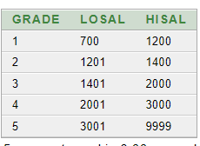

2. select deptno from dept;

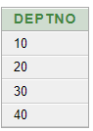

3. select (sal+sal\*0.05) "5% Increment" from emp;

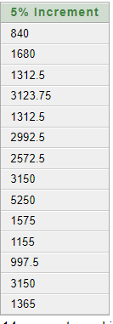

4. select ename,sal,(sal+sal\*0.05) "5% Increment" from emp;

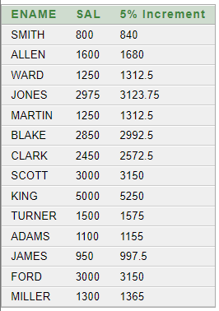

5. select \* from emp where ename='BLAKE';



6. select ename||' is hired on '||hiredate||' as a '||job "Description" from emp where hiredate

between '17-dec-80' and '28-sep-81';

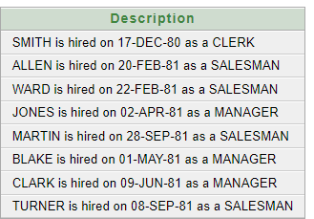

7. describe emp;

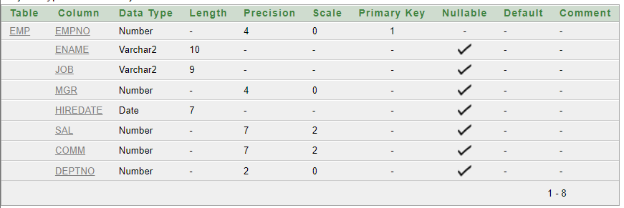

describe salgrade;

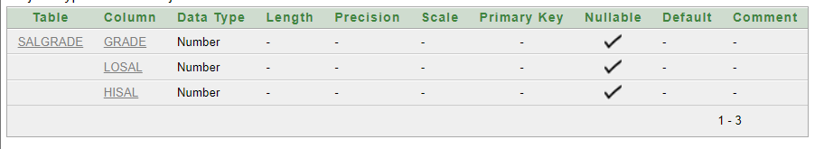

describe dept;

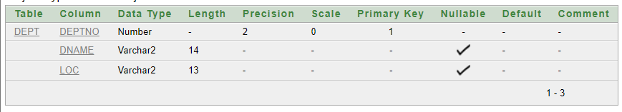

describe bonus;

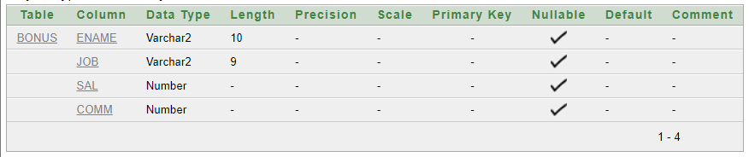

8. select distinct job from emp;

